**DIAGNOSTIC DRIVE THRU**

*(MANUAL & WORK AROUND)*

1. 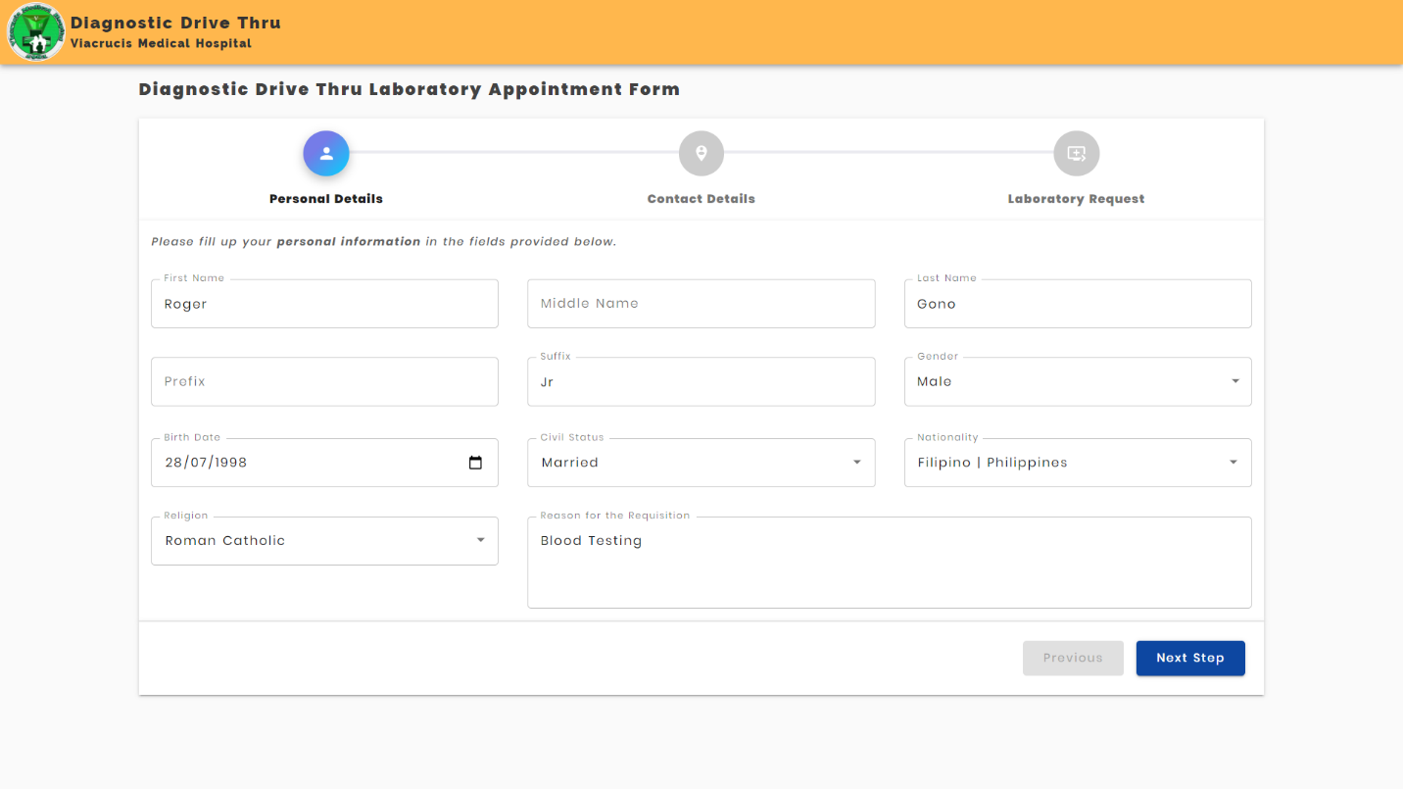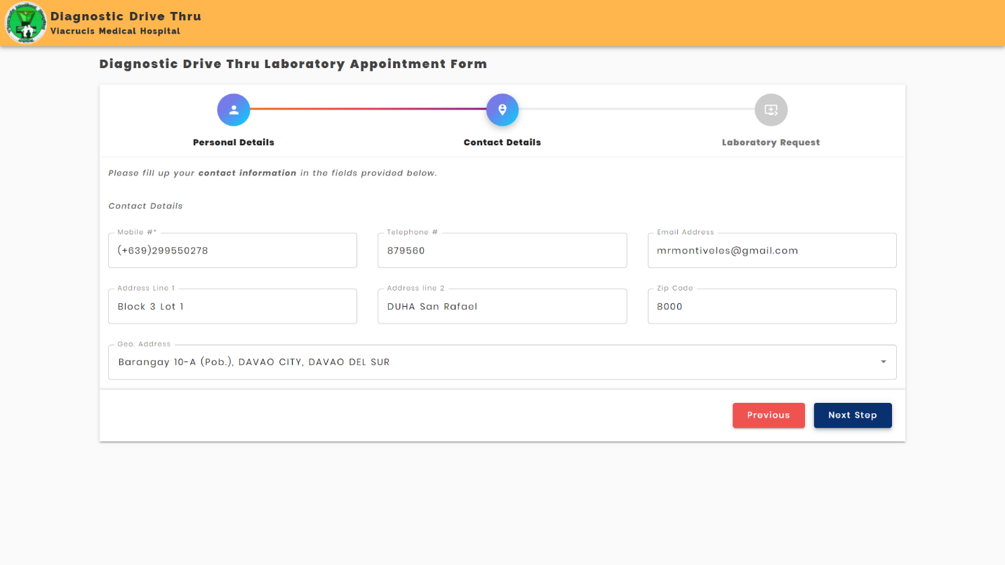Client Action: Clients can create their online laboratory request by **filling up the lab appointment form.**

- In the step 3 of the form, clients can select multiple Lab. Procedures that they want to avail.  
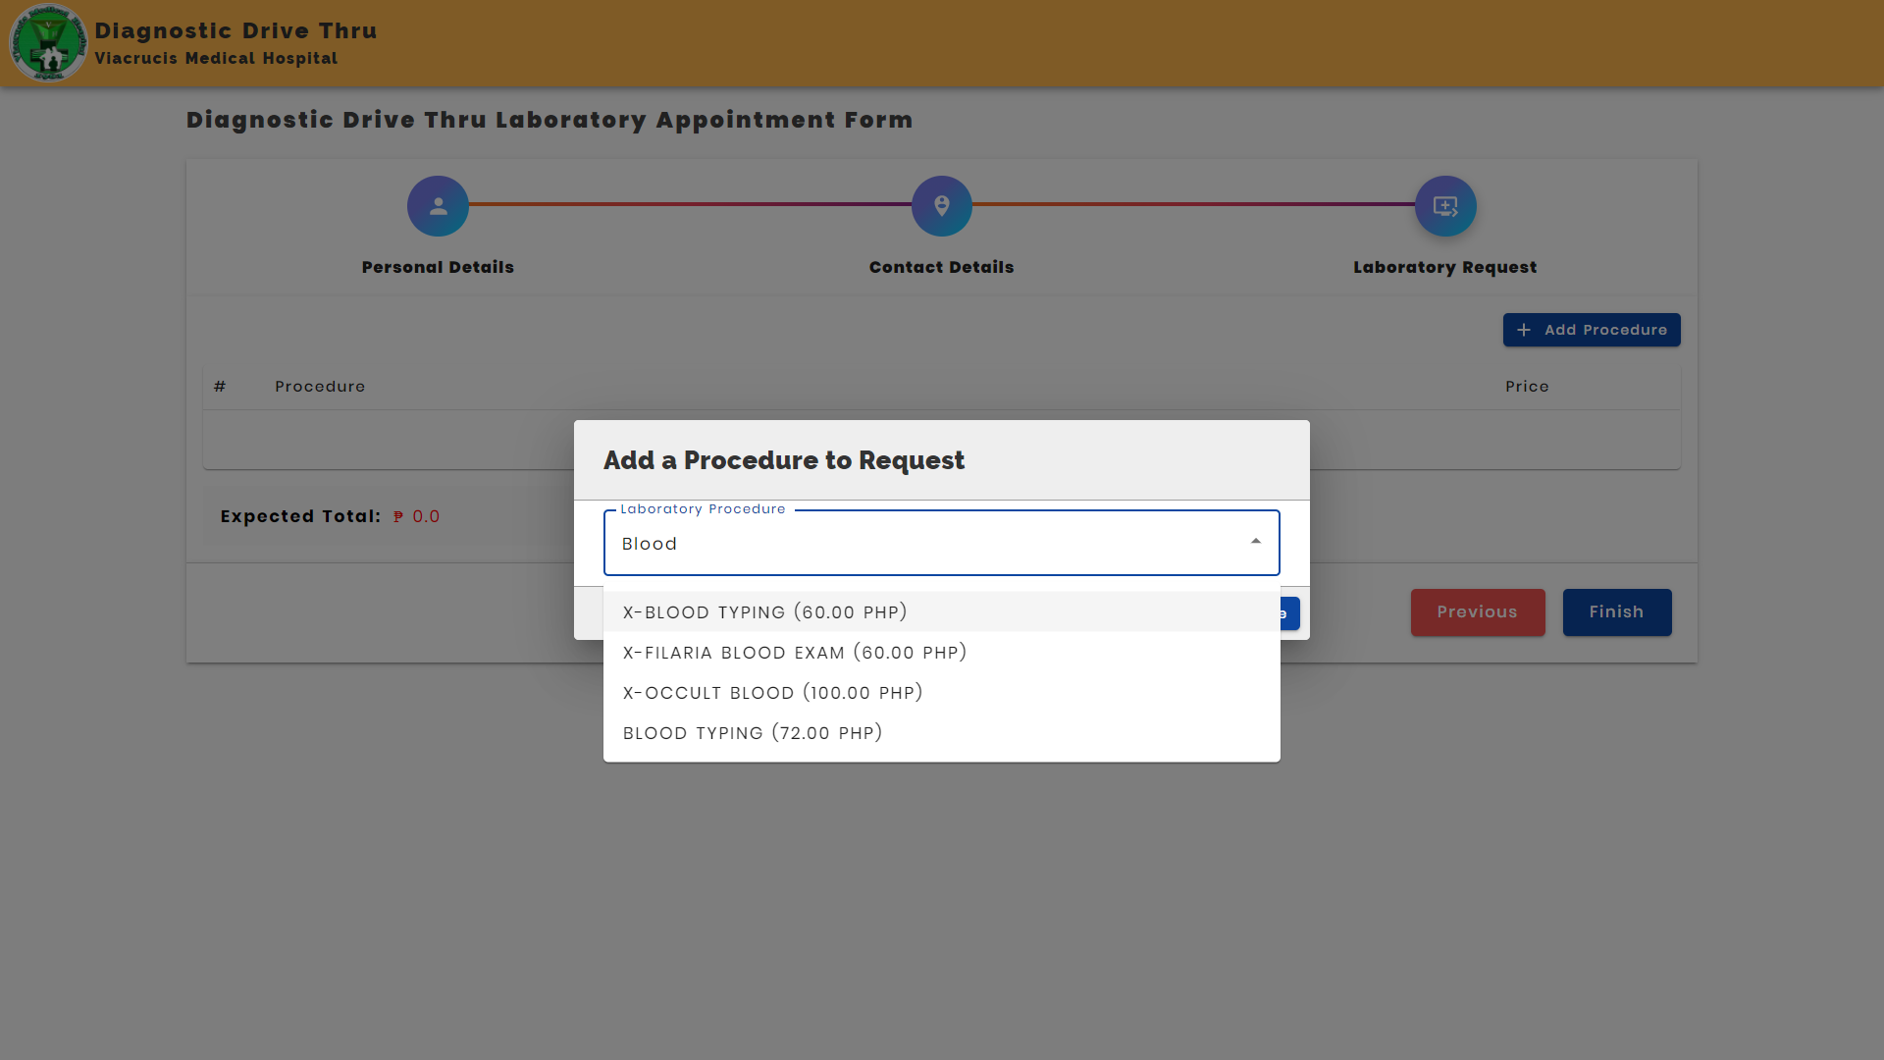

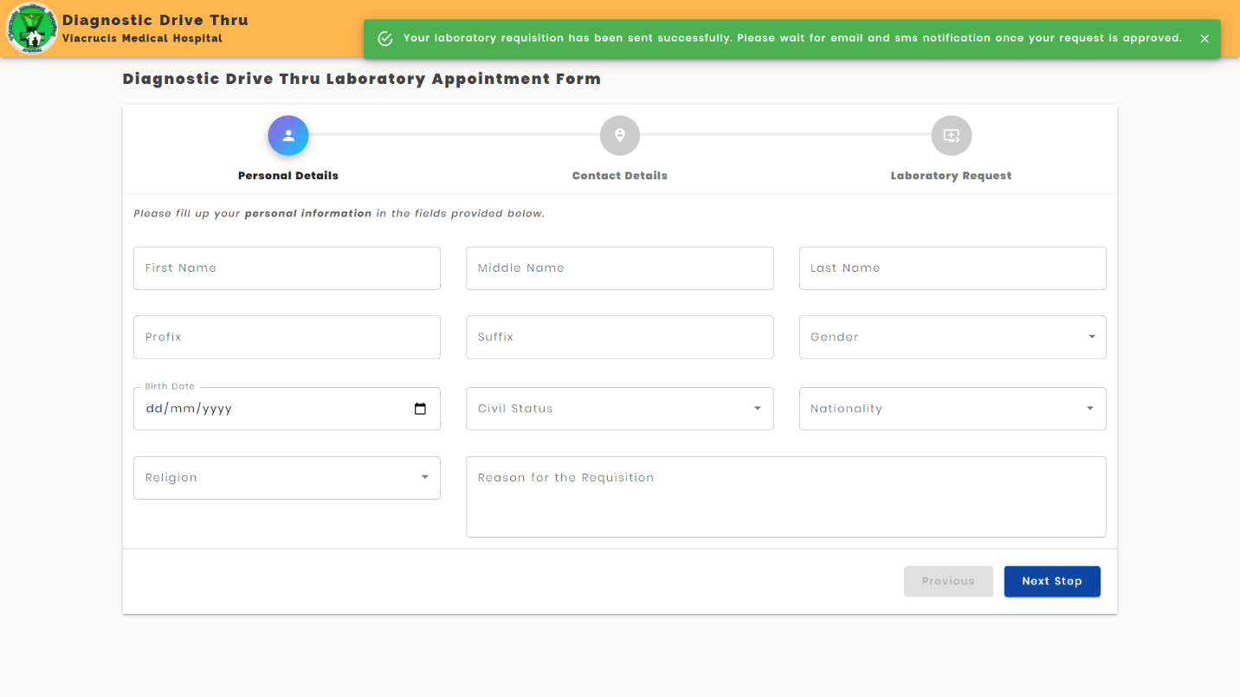Once completed, they will be prompted with a success message.

1. 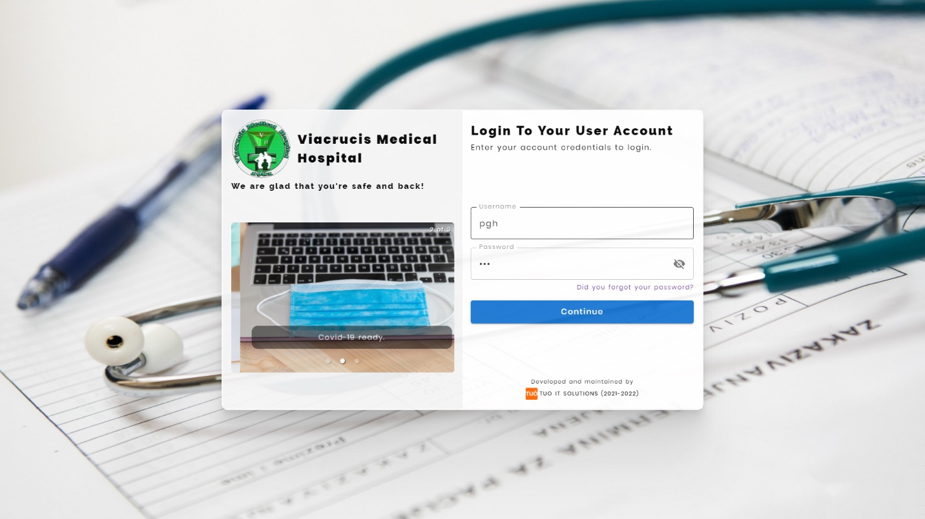The diagnostic Drive Thru administrator can now view the Lab. Requests by logging into their accounts.

They can view all the lab requests with their status accordingly. They can also view and manage the request by clicking the name of the client.

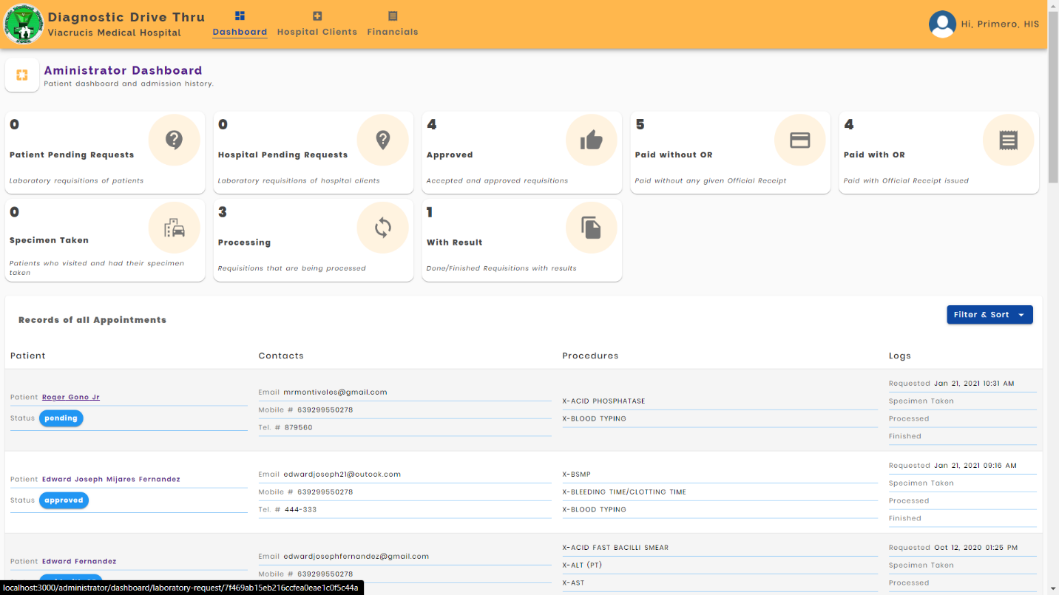

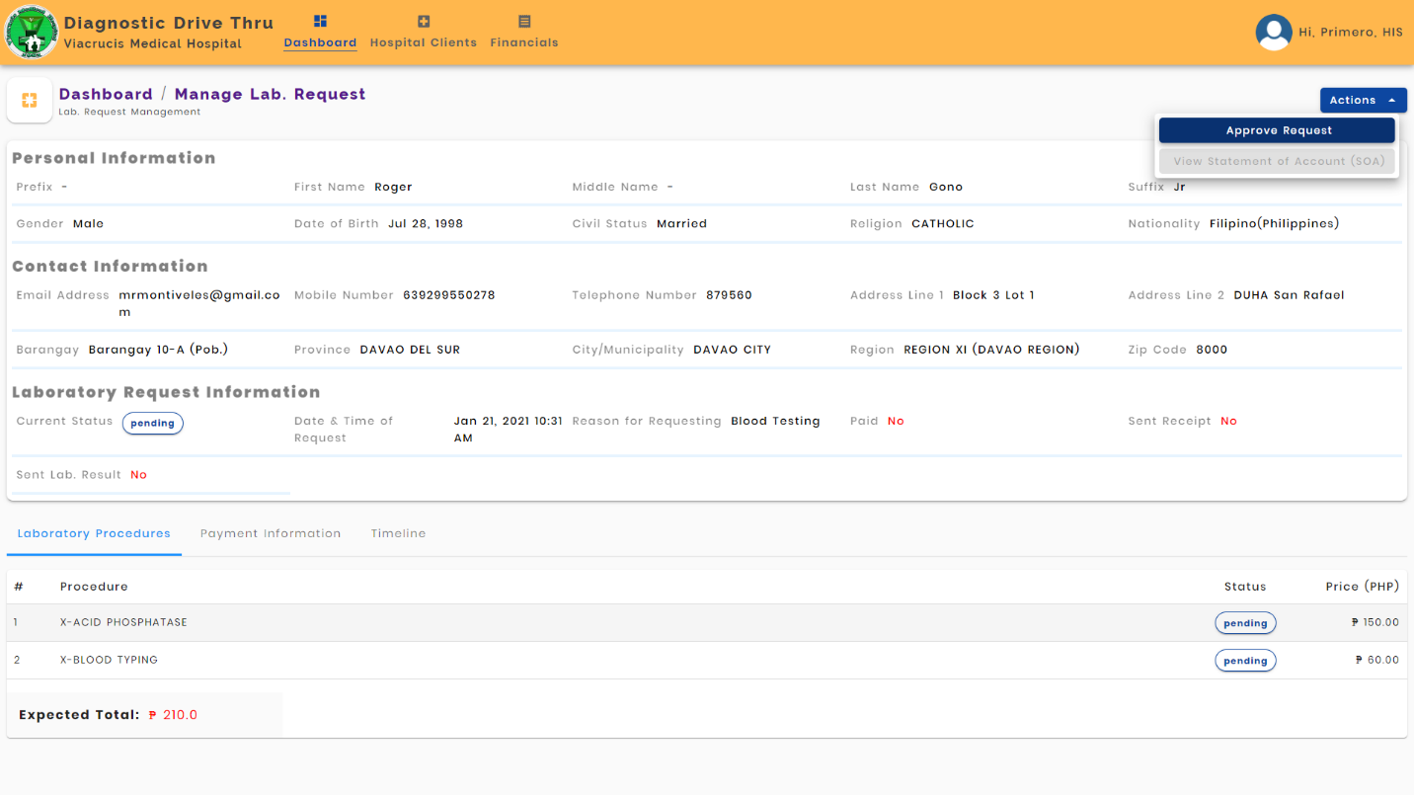To APPROVE the request, click the Actions => Approve Request

Admin Action: The system will automatically send a PAYMENT LINK to the client into their email address. At the same time, an OTP (One Time Passcode) will also be sent to the client’s phone number. Once succeeded, a success message will be prompt and the request status will be changed to APPROVED.

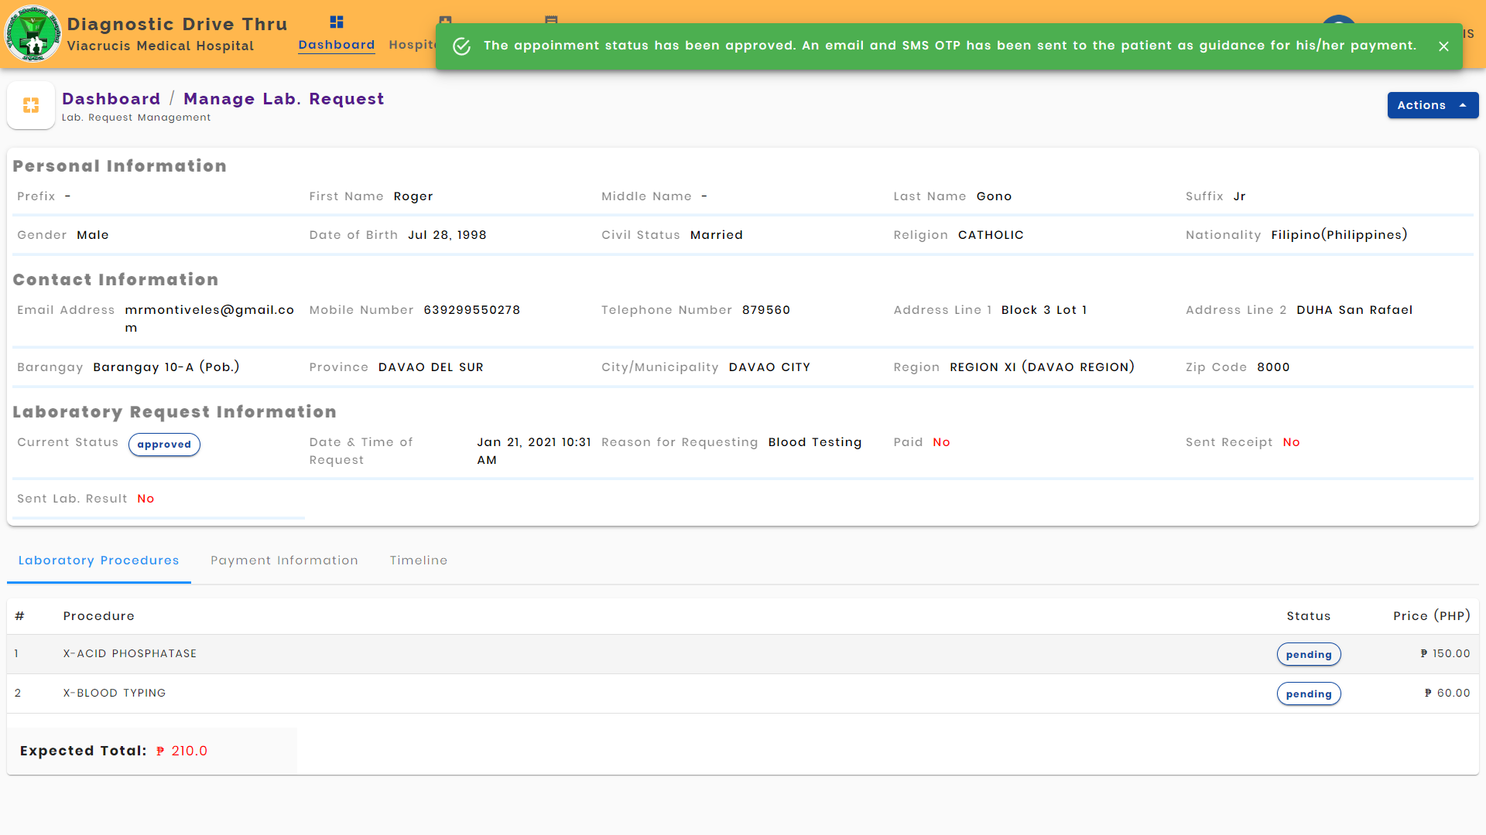

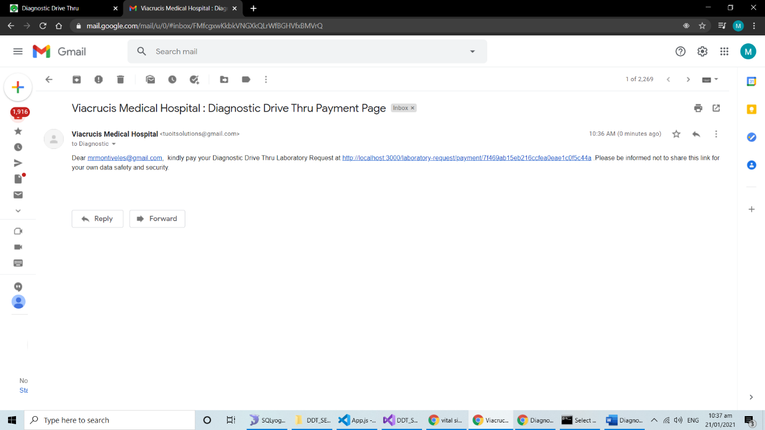Client Action: The Client can now check the payment link the email address that they have provided.

Client Action: Once the payment link is clicked, they will be redirected to the payment page. To start the payment, they will have to enter the OTP that has been sent in mobile number that they have provided.

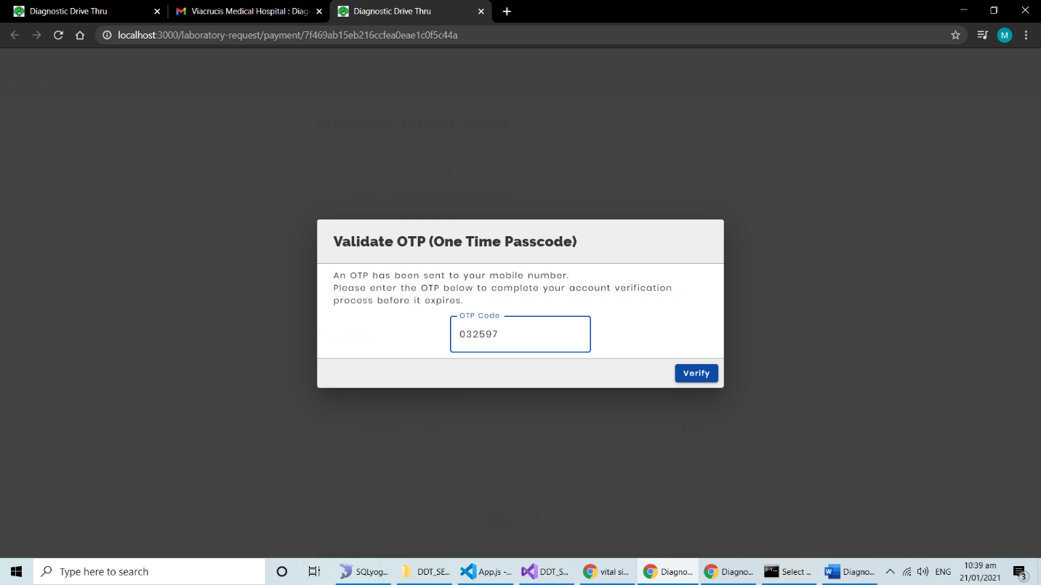

Client Action:

* After the OTP has been verified, a Lab. Request Invoice will be shown in the payment page. They can review their own information as well as the lab procedures that they have availed.
* They can click the payment buttons below to process their payment.

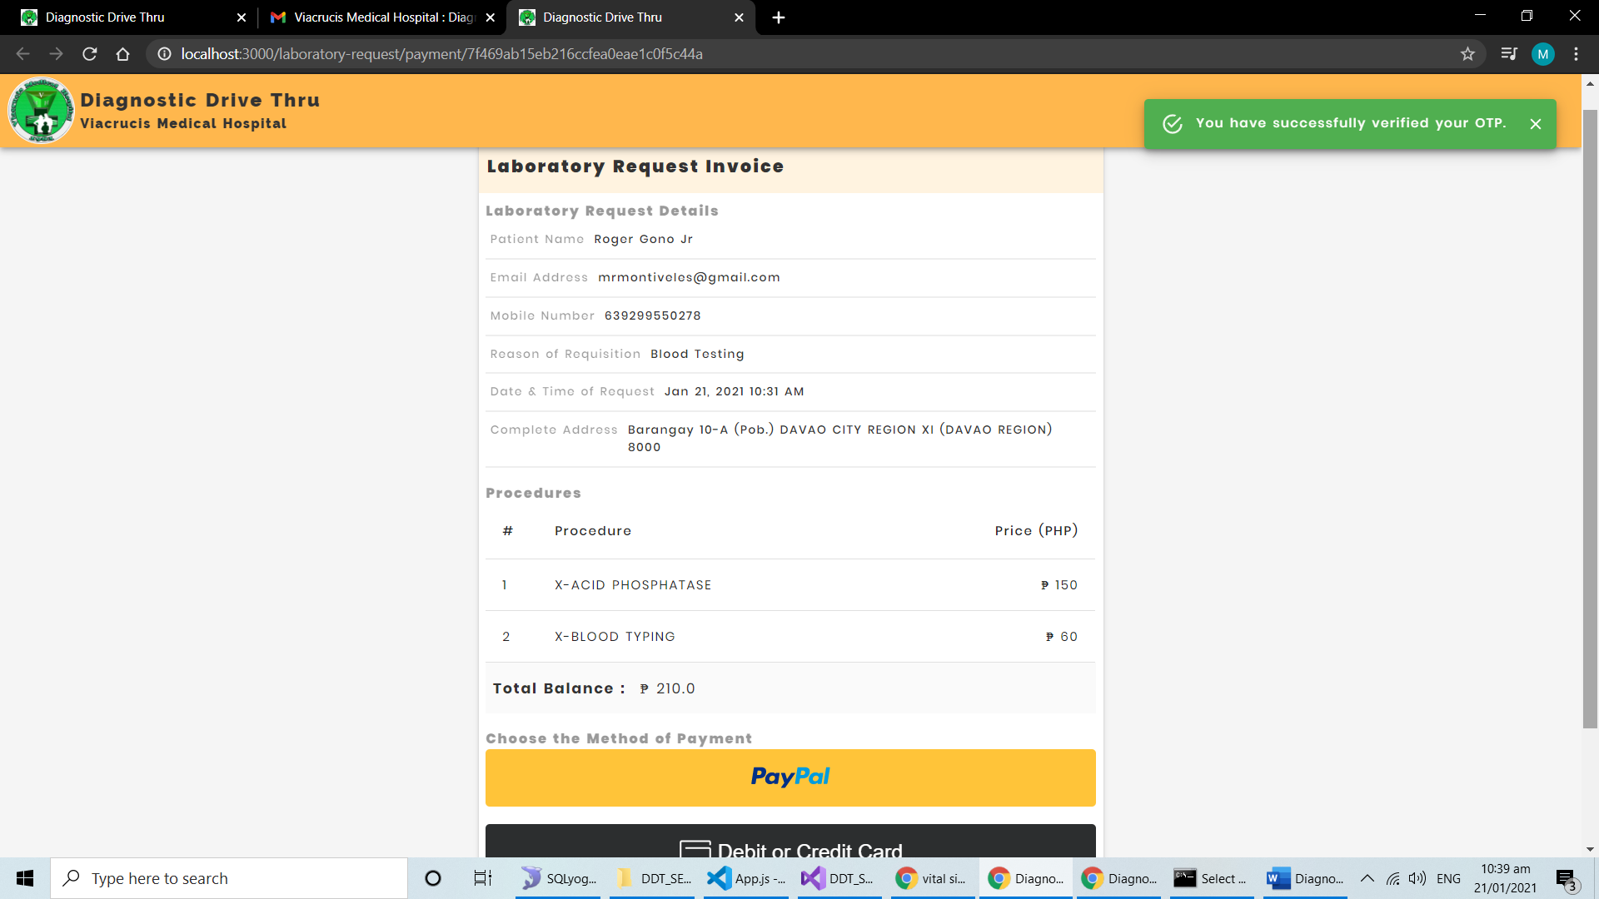

PAYPAL PAYMENT

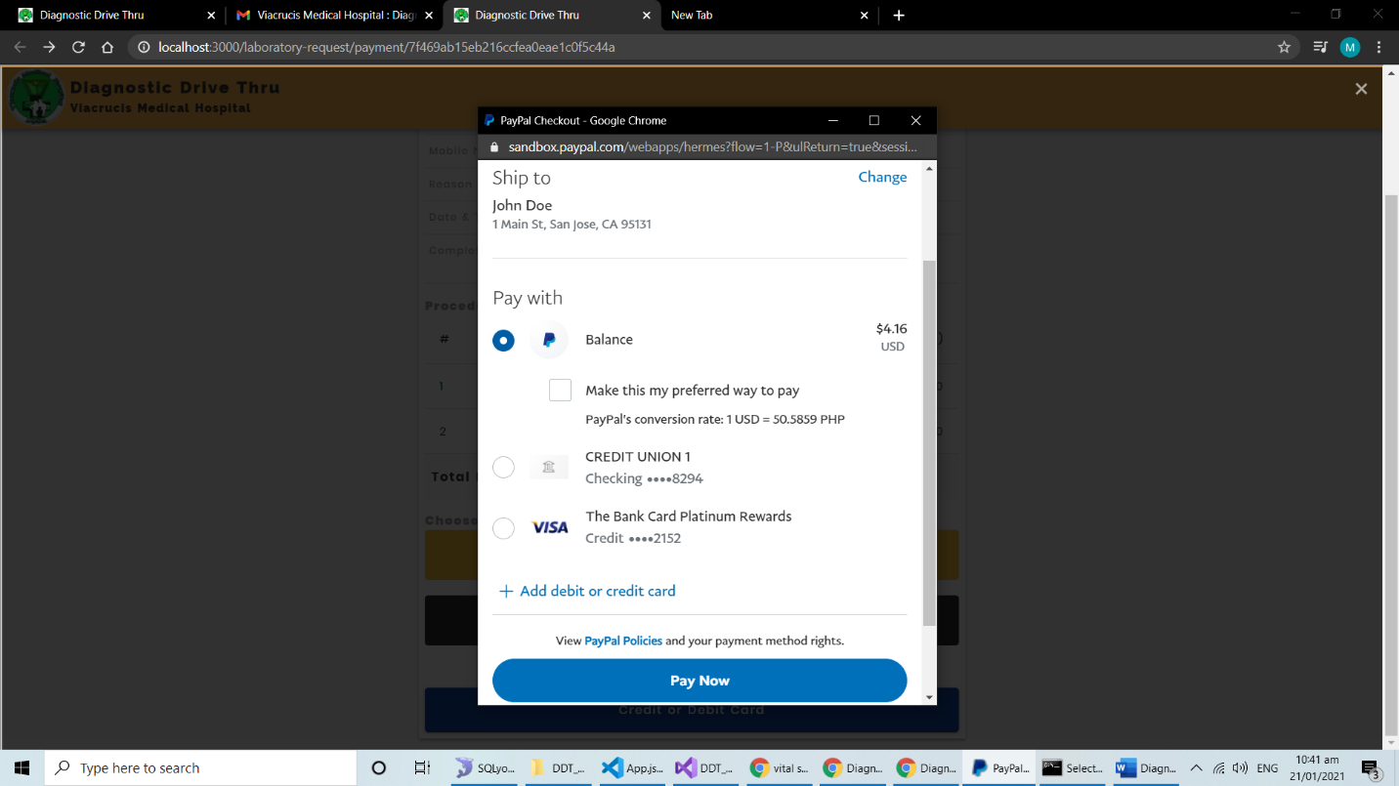

CREDIT/DEBIT CARD PAYMENT

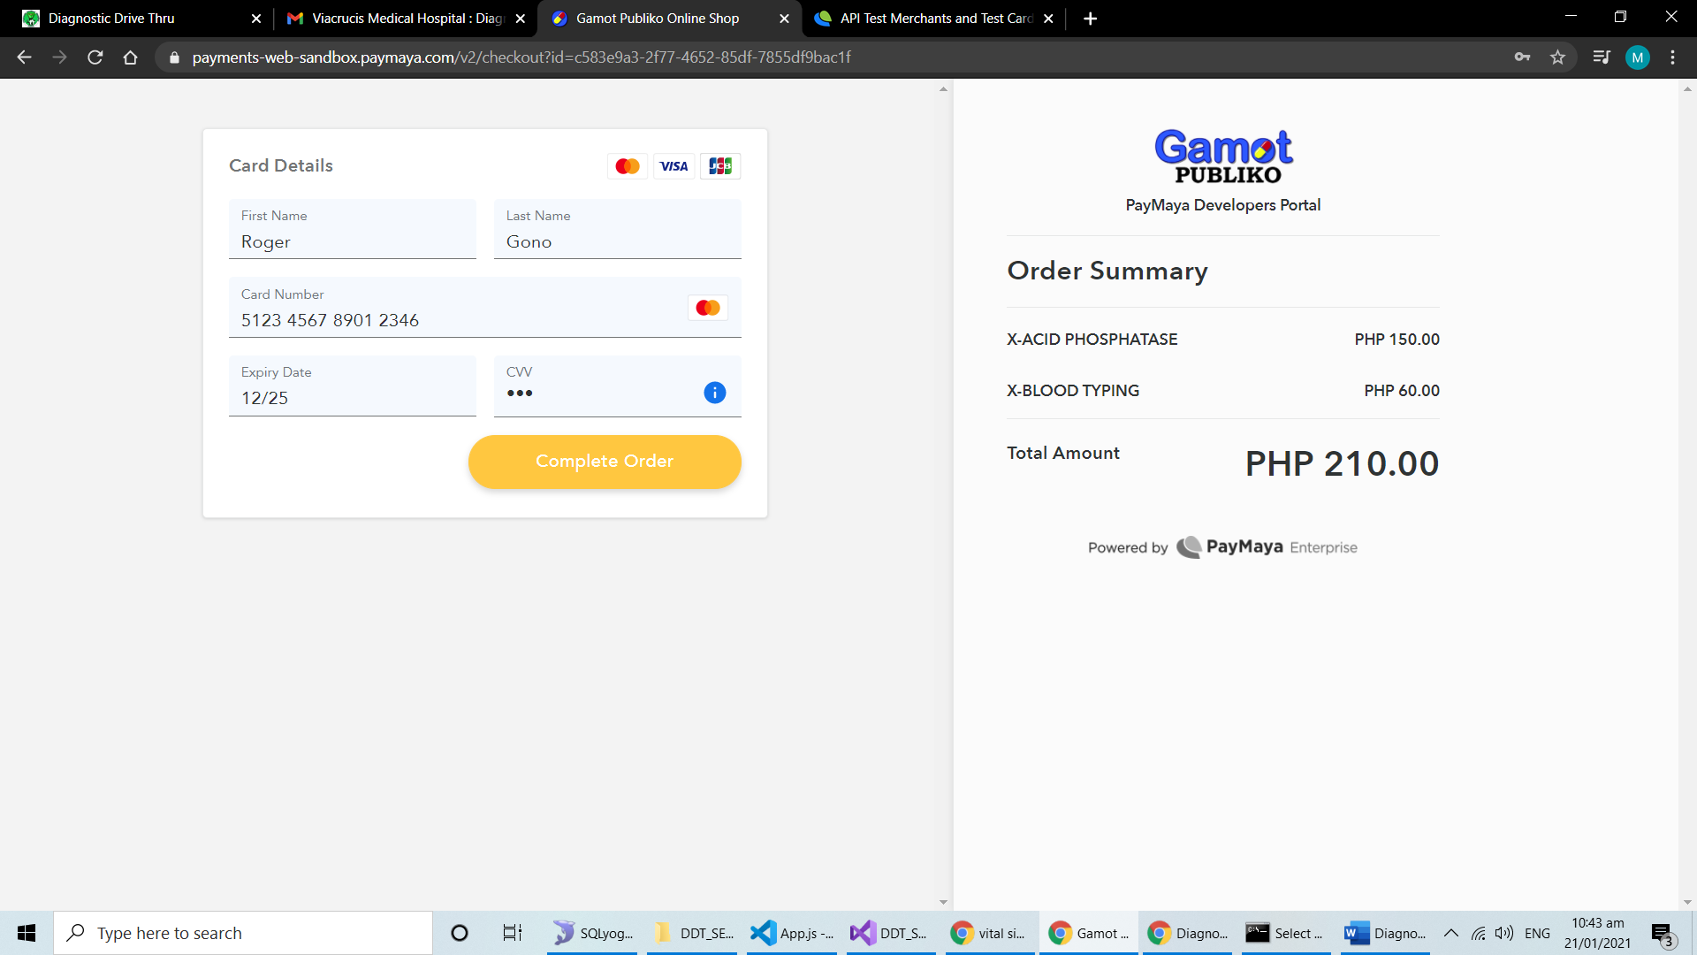

Client Action: When the payment process is successful, they will be prompted with a success message and the payment page will no longer be available.

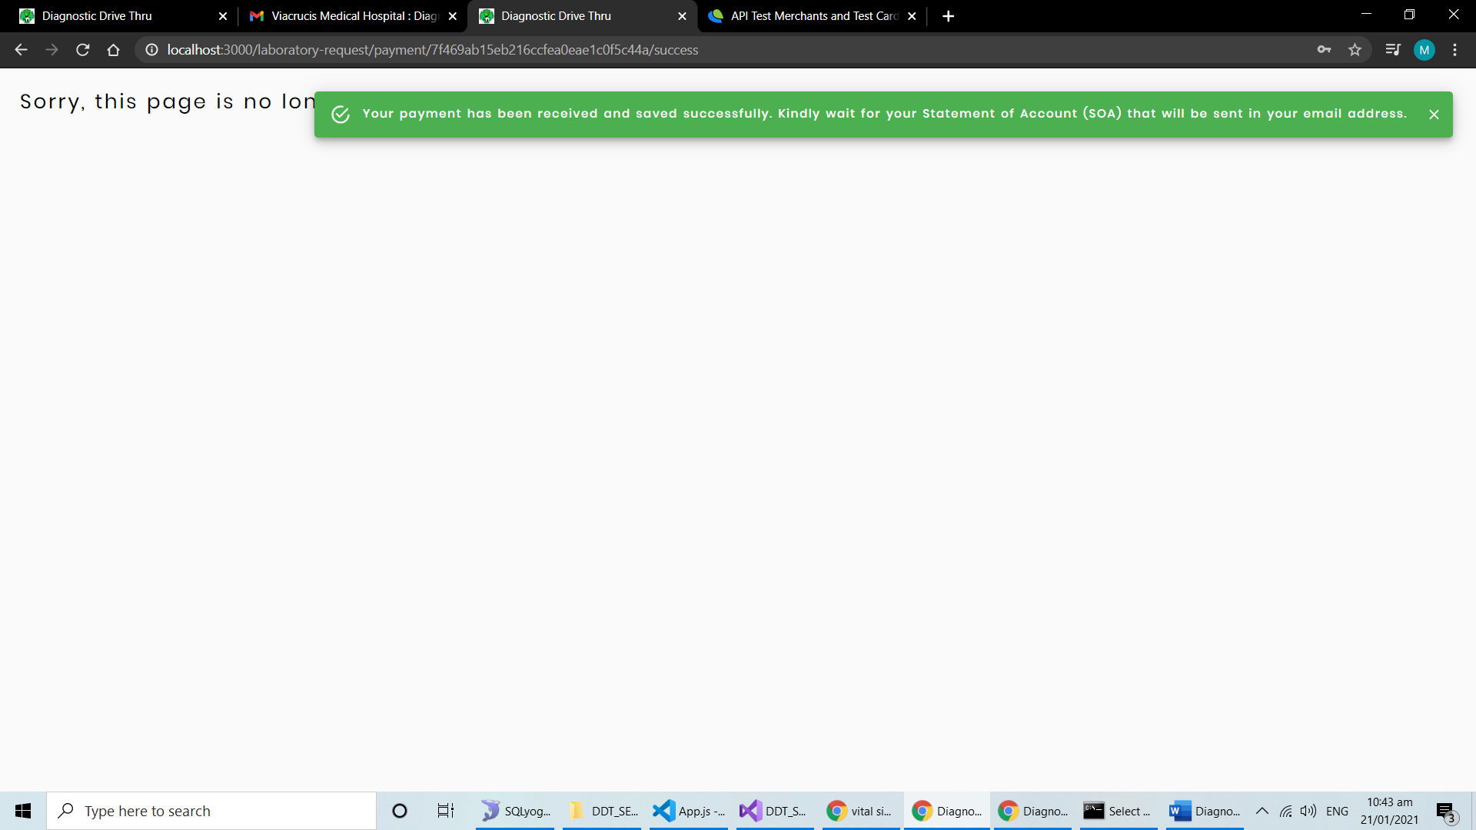

Admin Action: The status of the Lab Request will automatically change to **PAID WITHOUT OR**, thus they can view the temporary Official Receipt: Actions -> View Statement of Account

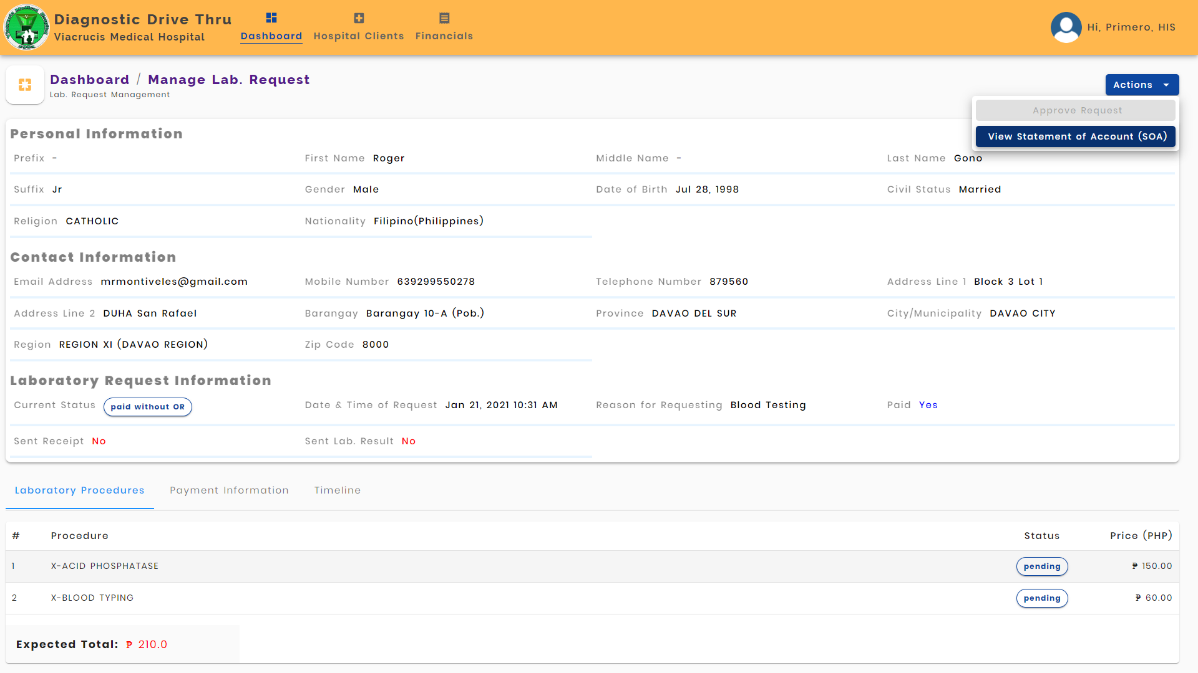

Admin Action: Verify the SOA information and email it to the client.

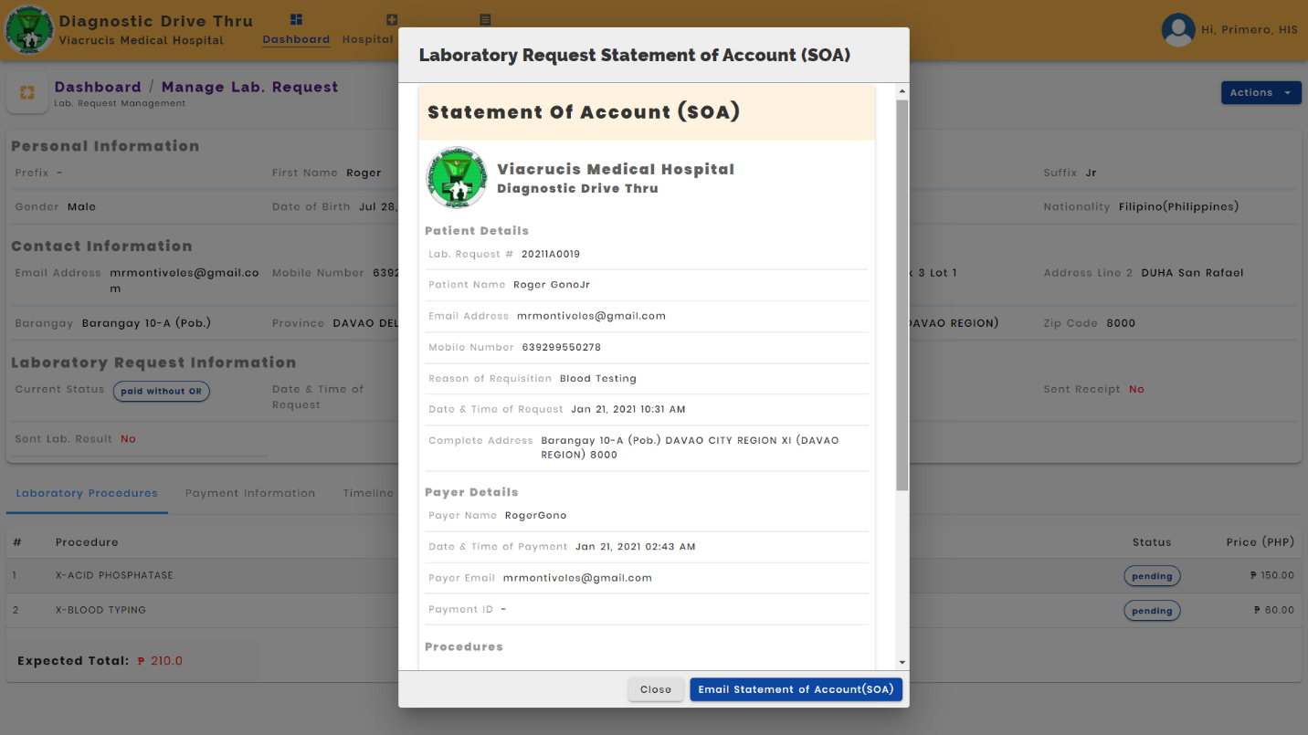

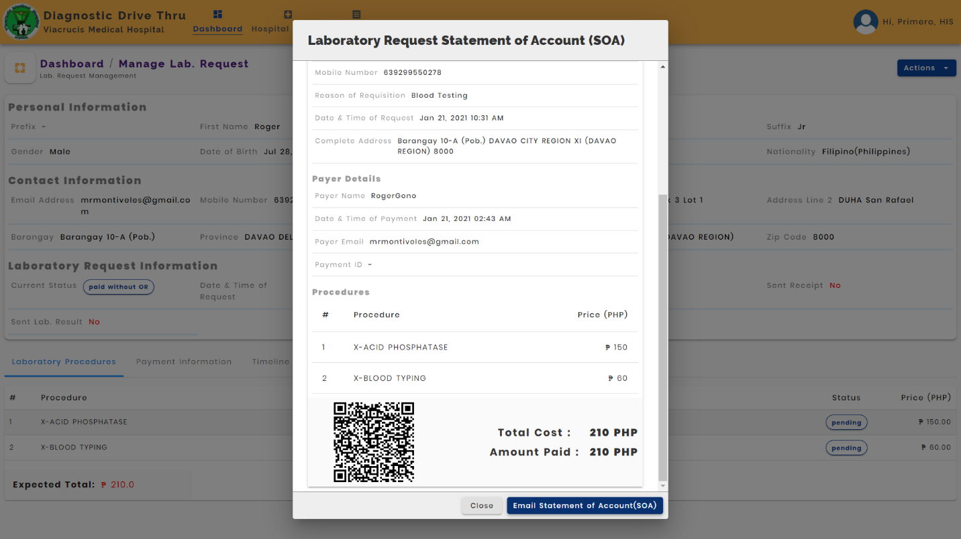

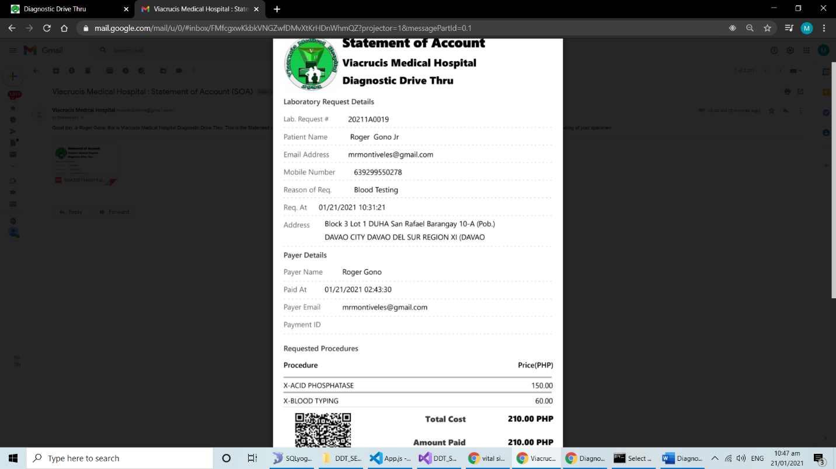Client Action: Clients can now check SOA in the email that they have provided. **The OTP will be asked by the hospital Lab personnel to be presented when the client visits the hospital.**

Lab Personal: Login to their account.

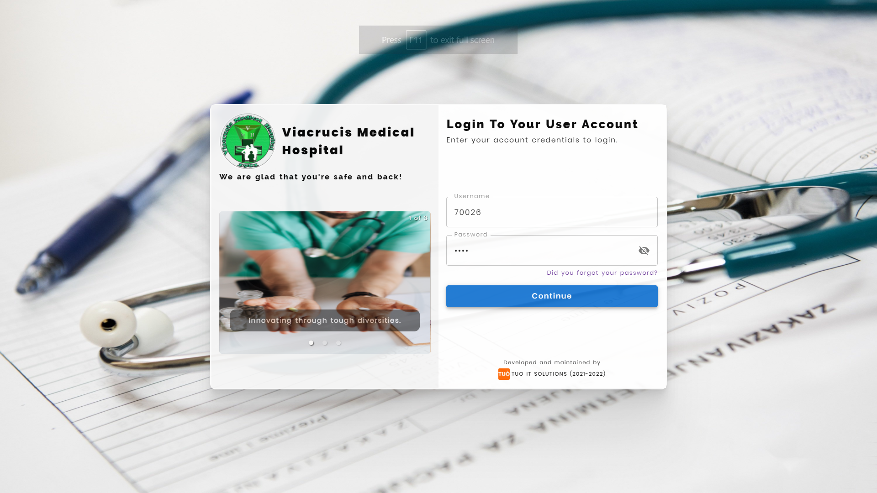

Lab Personal: Lab personal can also view all the confirmed lab requests. **They are allowed to scan the Lab Request QR Code of the Clients by clicking the scan button in the header of the page.**

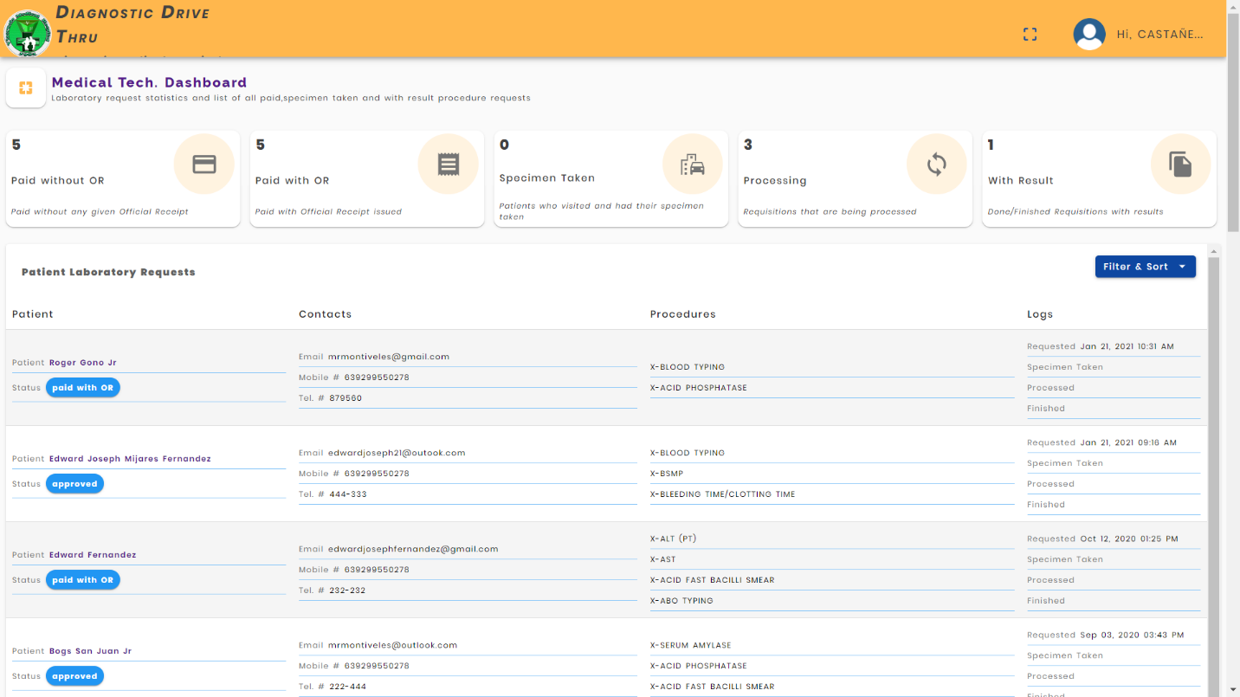

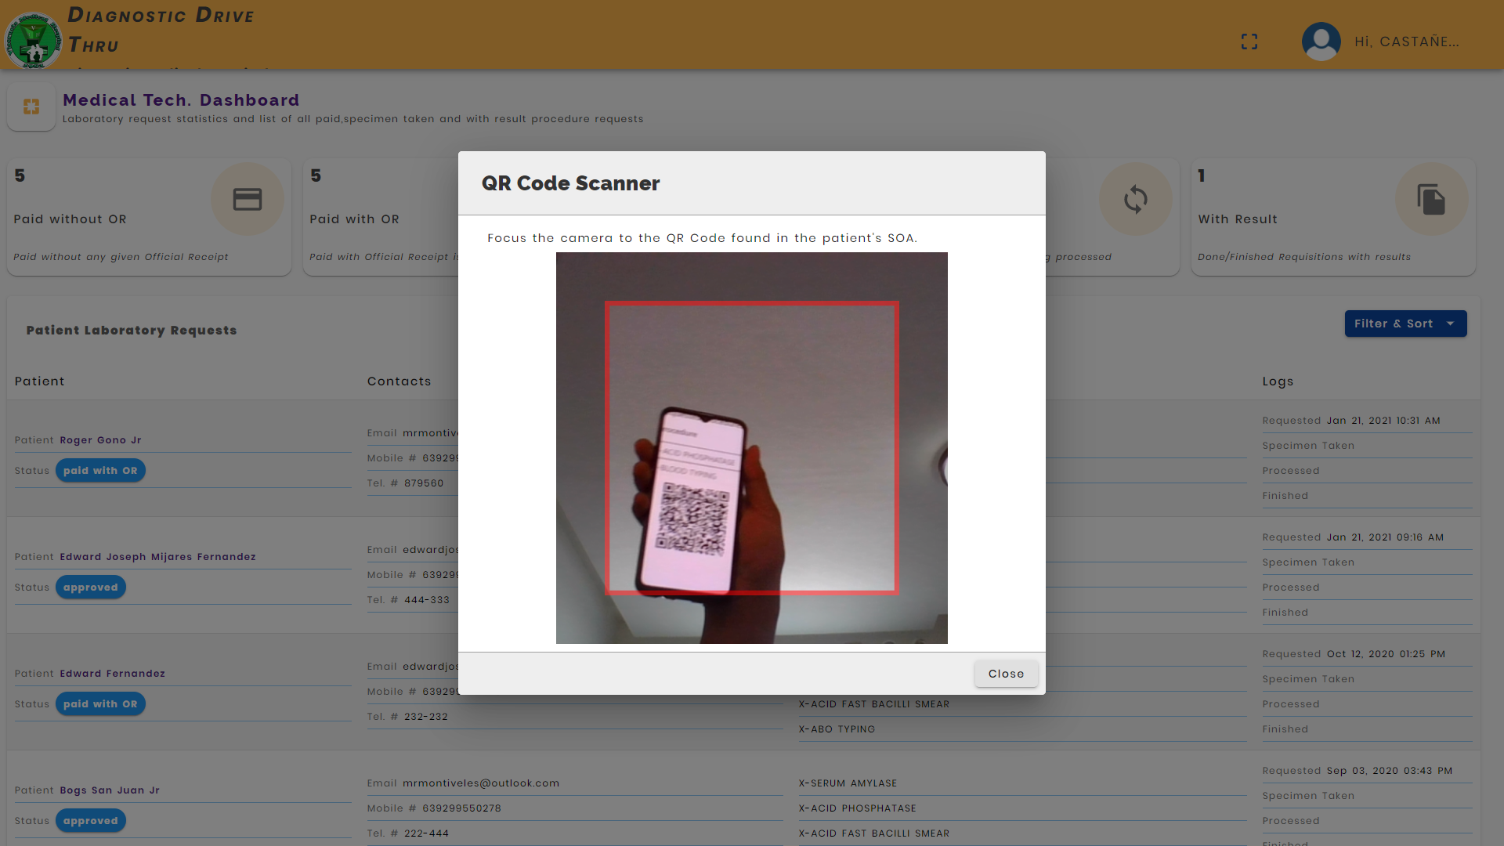

Lab Personnel Action: When the QR Code is verified, they can view and manage the lab. Request information.

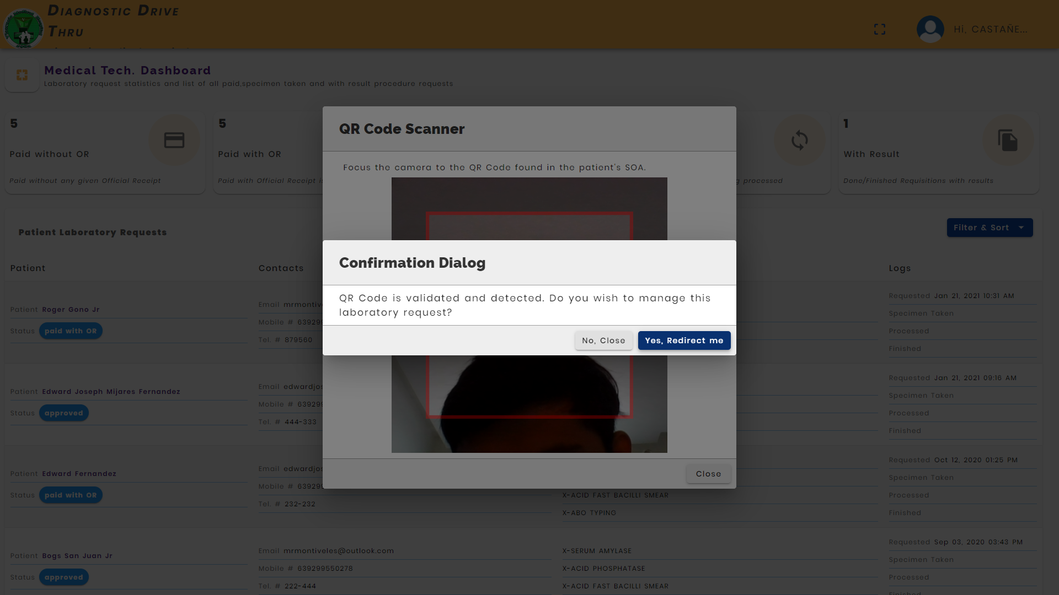

Lab Personnel Action: They can change the status of the lab procedure in the Actions Button.

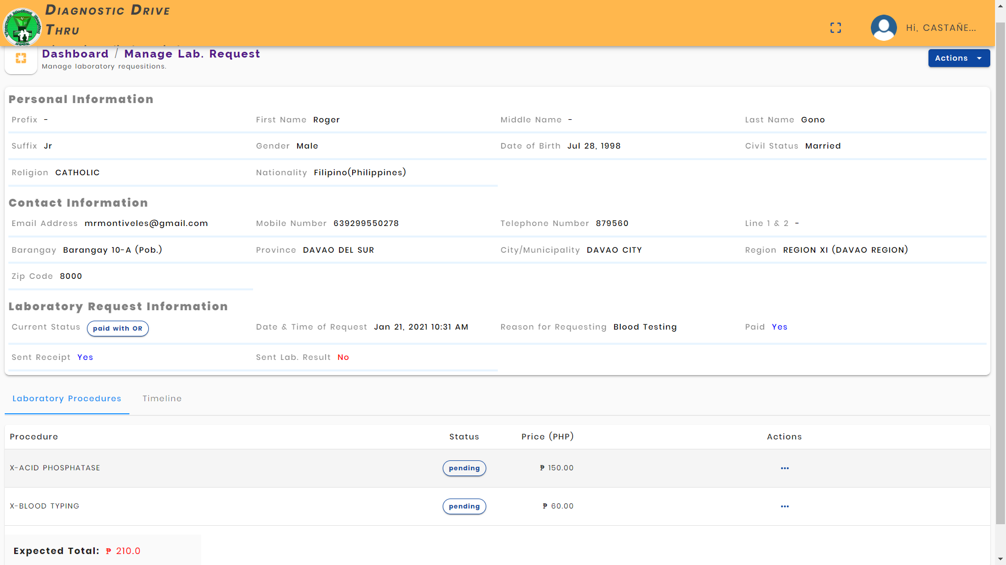

Changing status to **SPECIMEN TAKEN**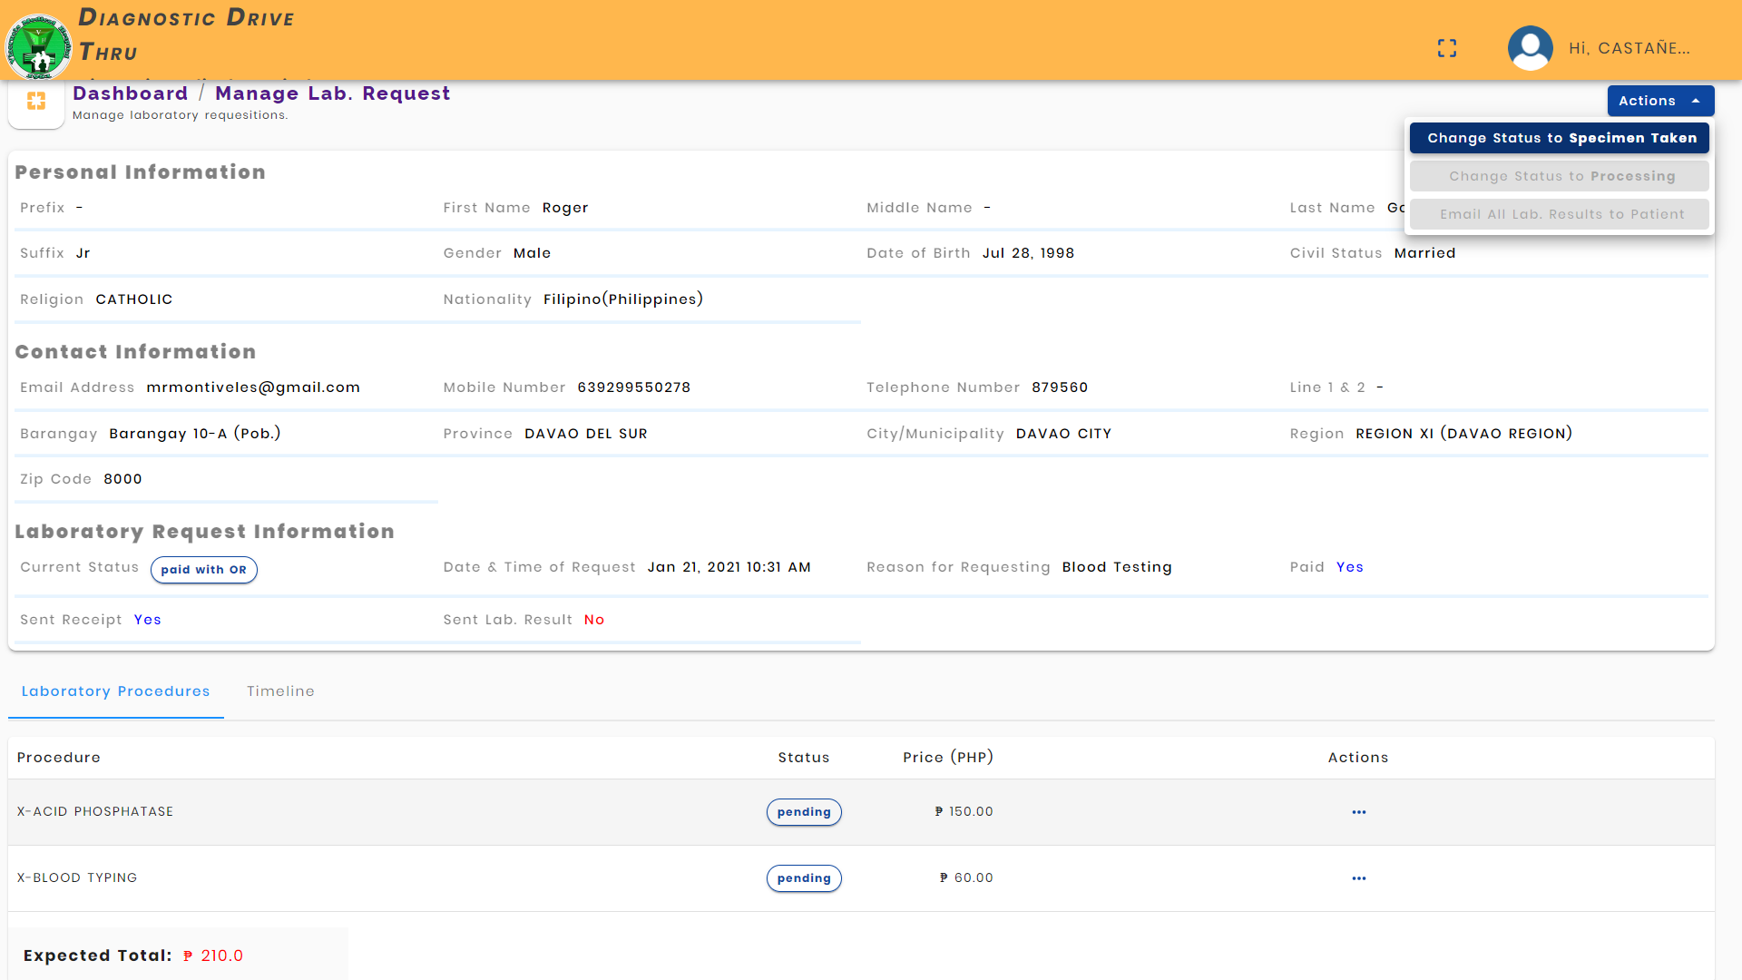

Change Status to **Processing**

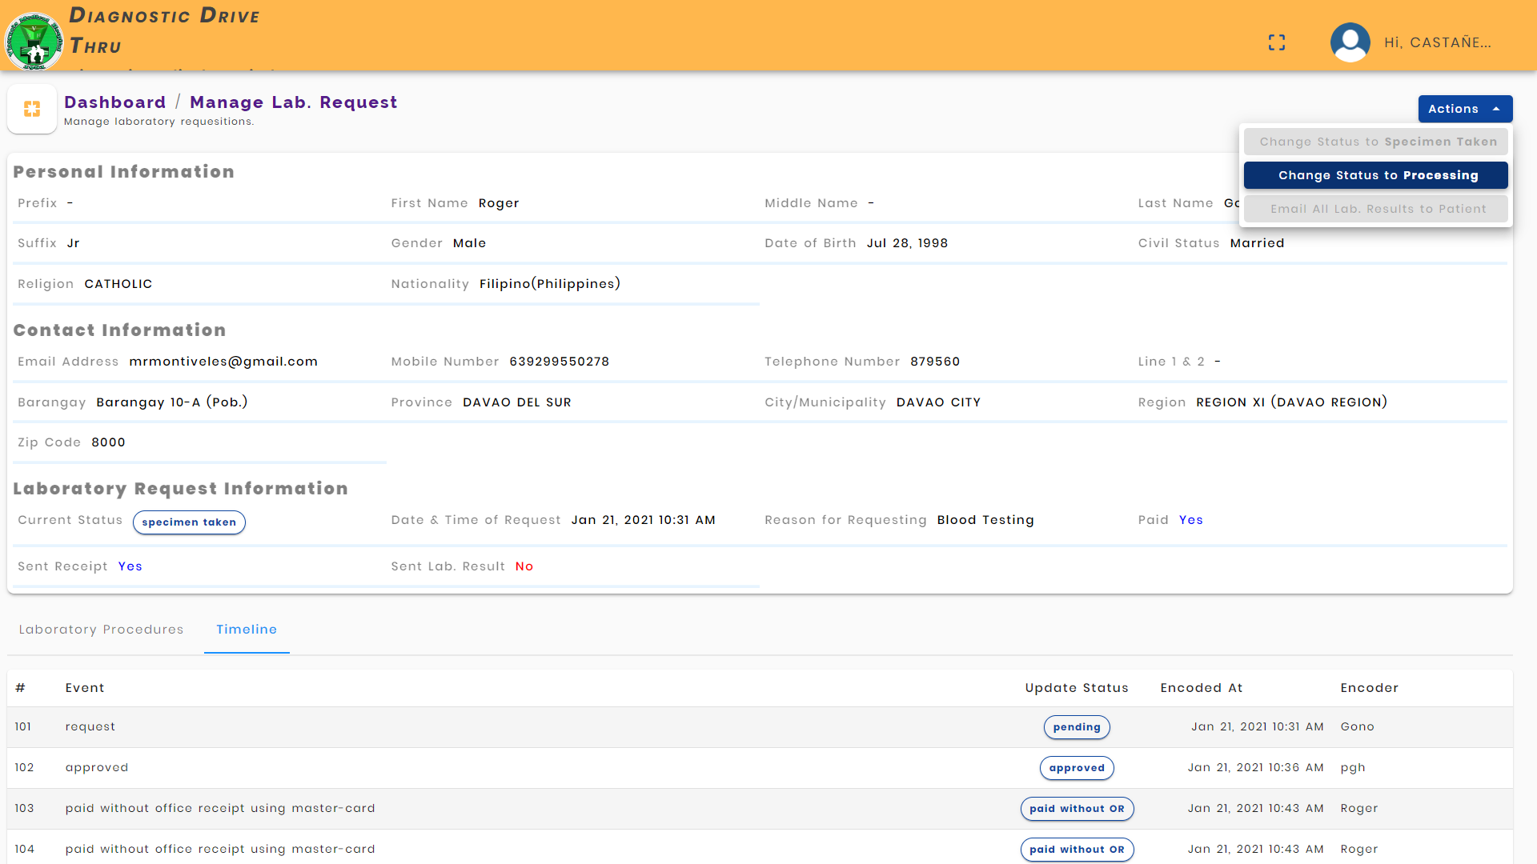

Lab Personnel Action: They can change the status of each laboratory procedure.

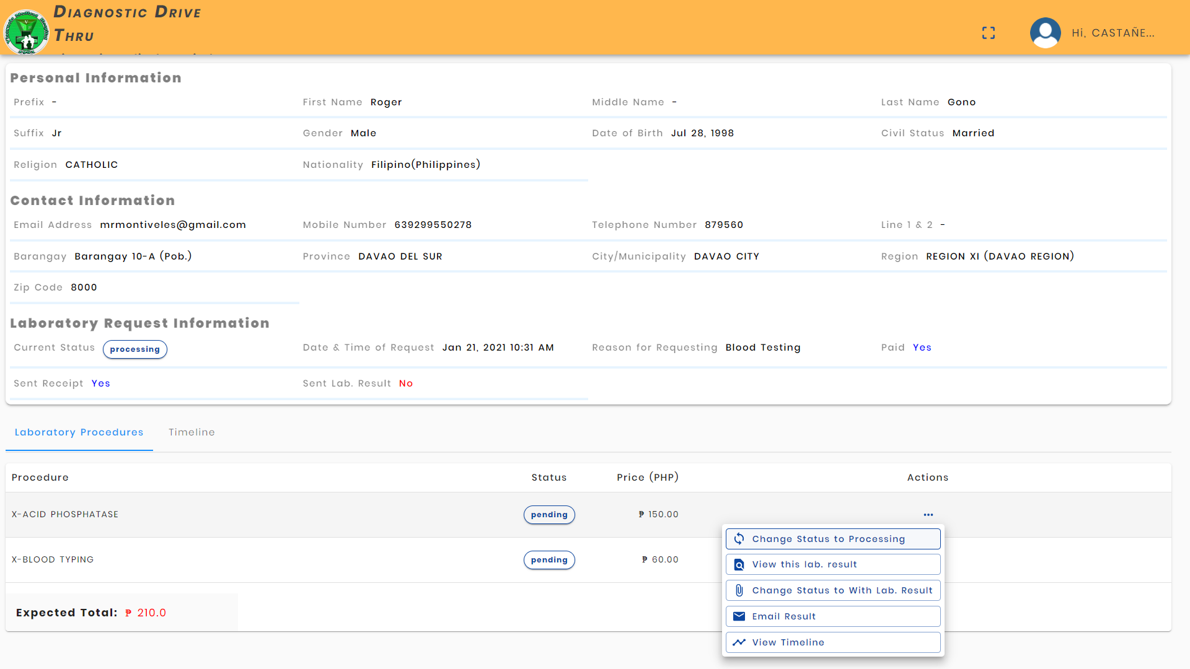

Lab Personnel Action: Adding a lab procedure result (file).

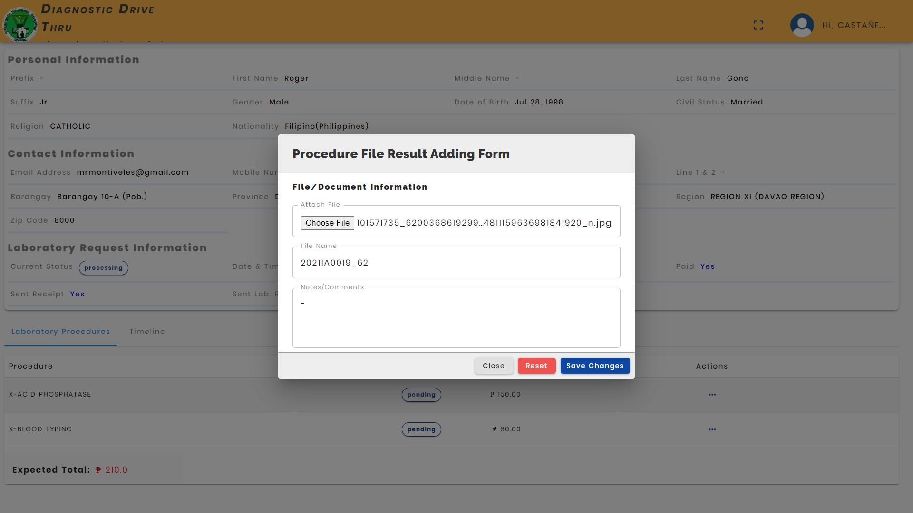

Lab Personnel Action: Email all procedure result (file) to the client.

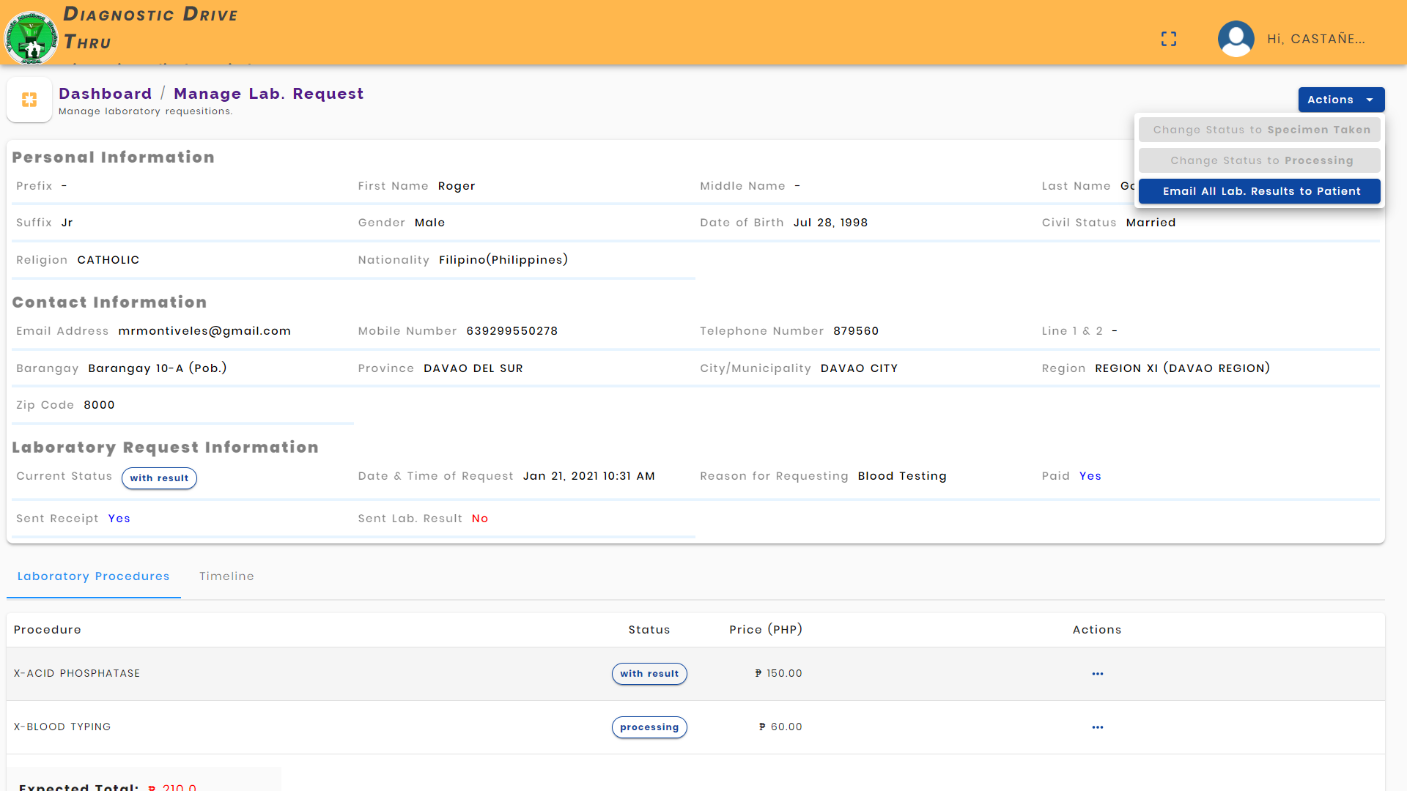

Admin Action: DDT has a feature of adding third party hospital (hospital clients) to refer patients in conducting their lab procedures in the hospital provider. Thus, DDT admin can add hospital clients.

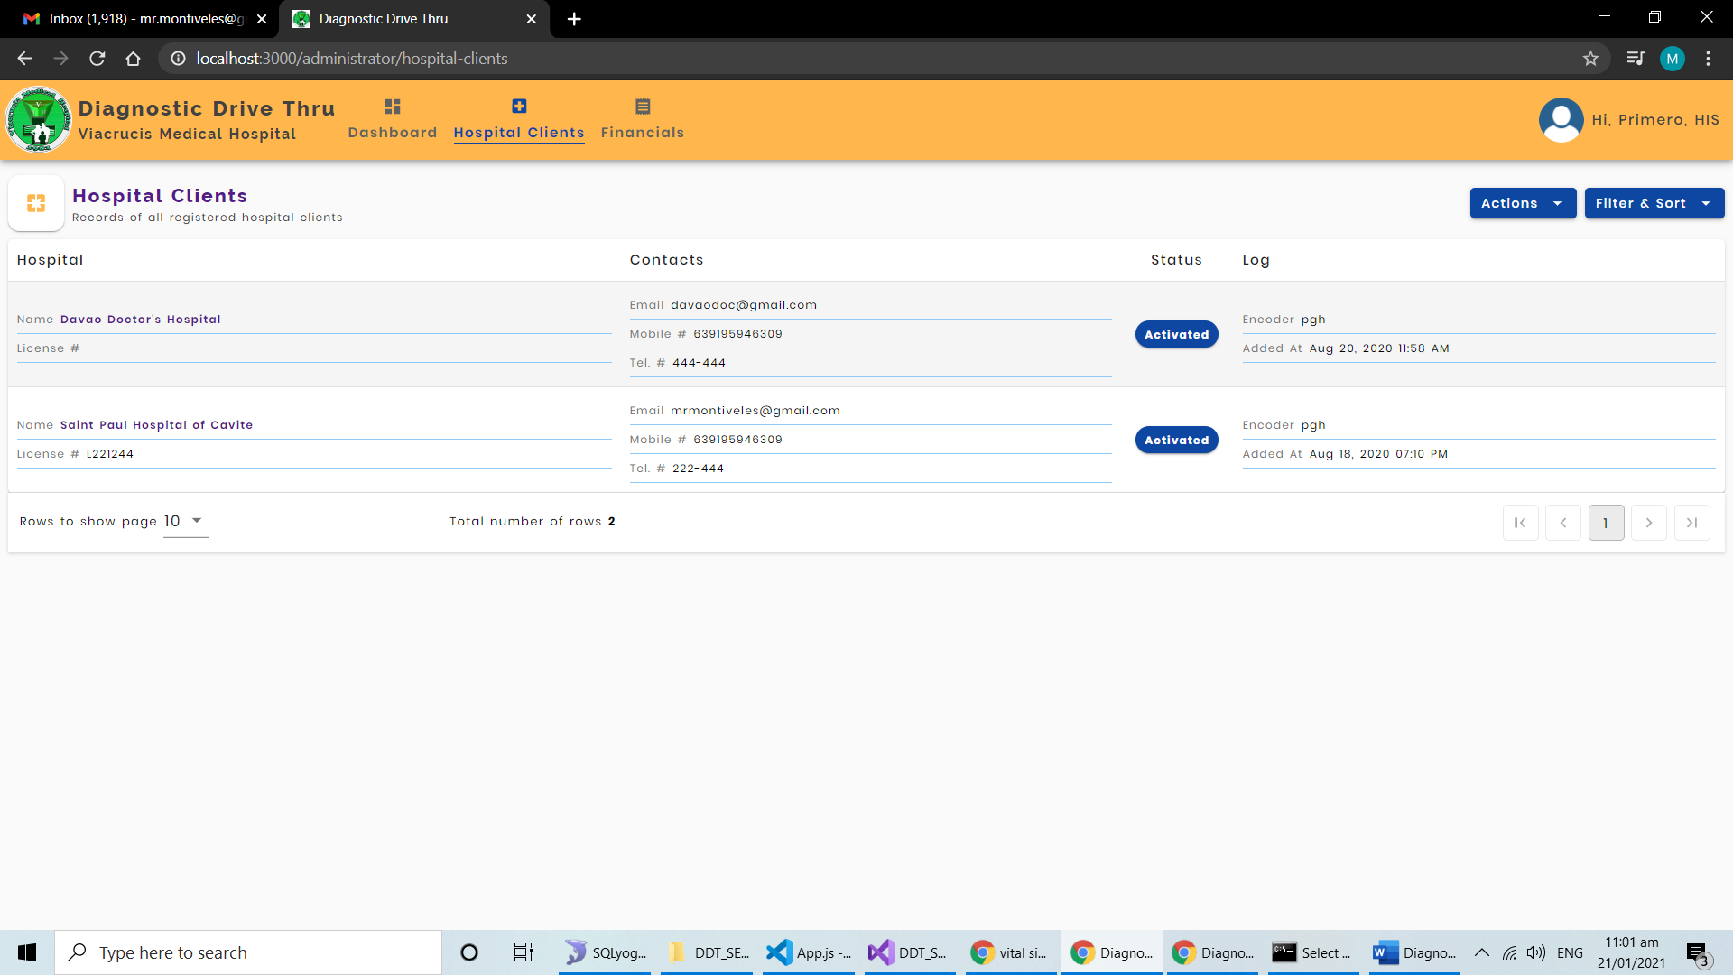

Admin Action: DDT has a feature of viewing the financials, especially the **Accounts Receivable** of the hospital provider.

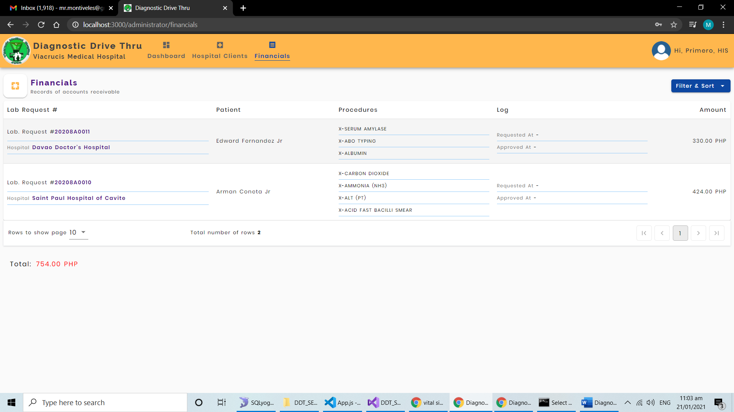

When the hospital client is registered by the admin of the hospital provider. They can login to their account using the credentials that are issued to the by the hospital provider.

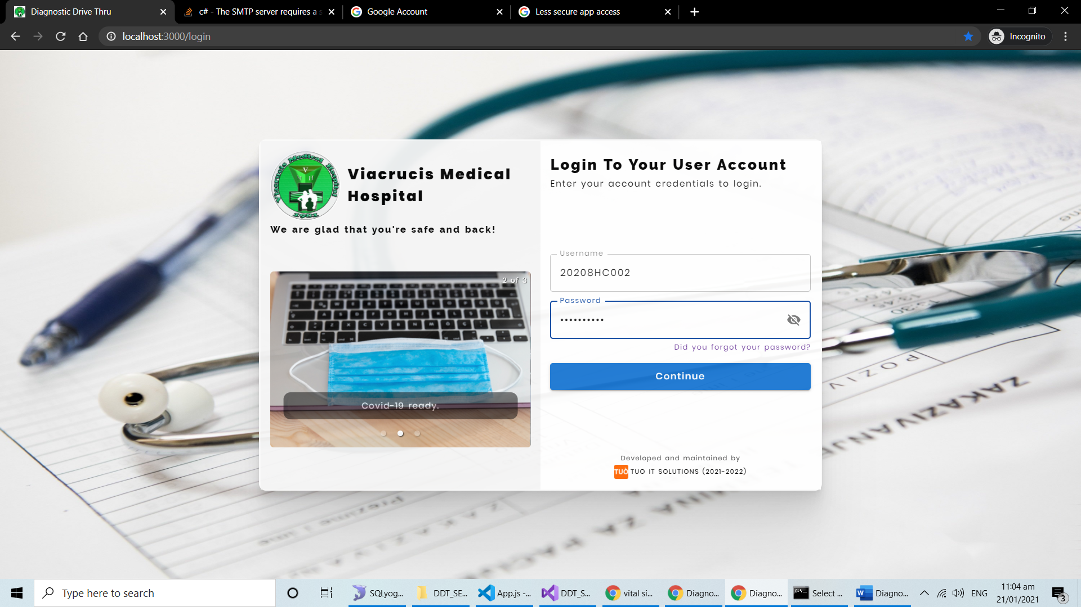

Hospital Client Action: They can view all the Lab. Requests of their patients.

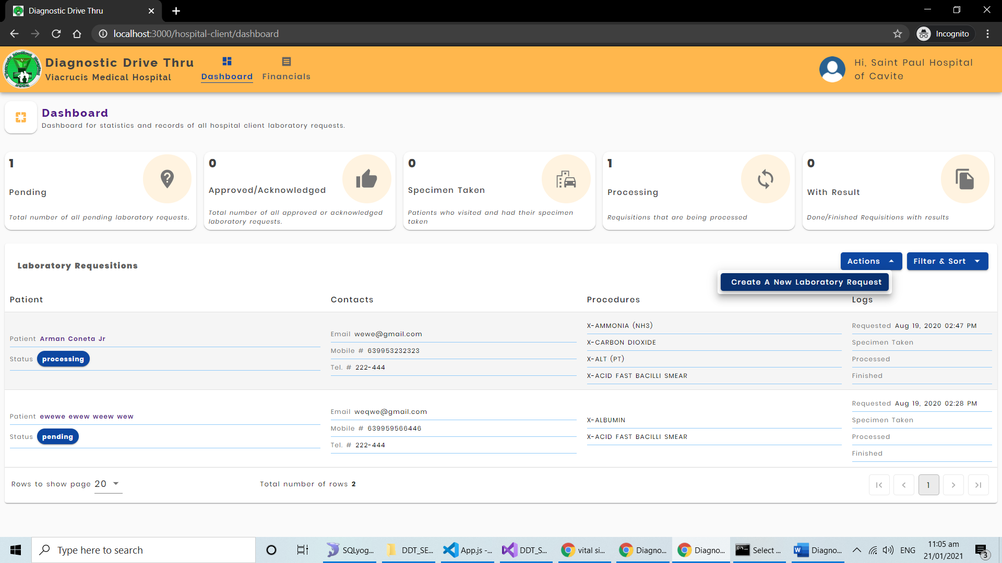

Hospital Client Action: They can also create a Laboratory Request Appointment for their patients. The process is the same in the client creation above.

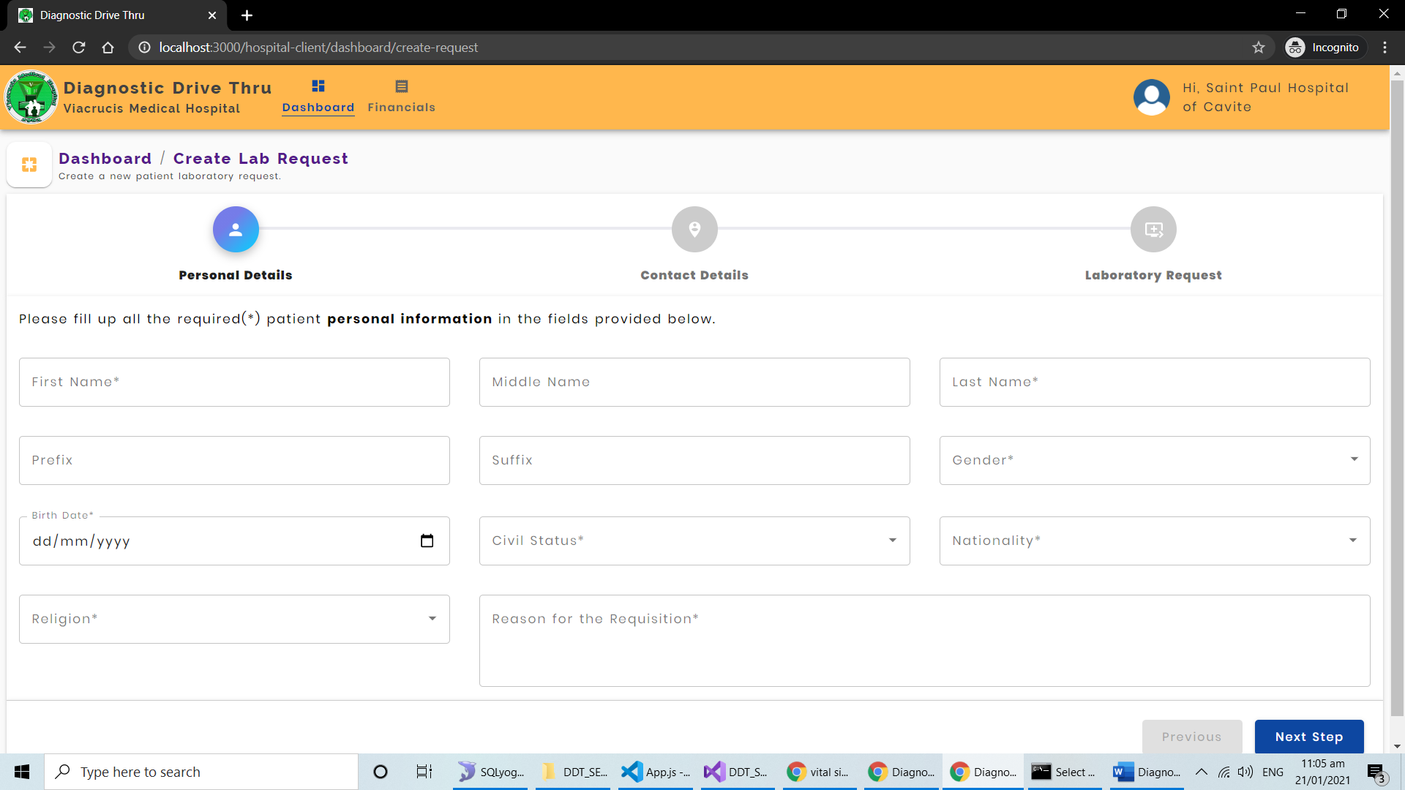

Hospital Clients can view all their accounts payable, in the financials menu.

